West Kalimantan Government Policy Regarding Environmental Issues (Karhutla) Forest and Land Fires in 2023
Adila Puspa Hestiantini¹
¹Department of Government Studies, Universitas Muhammadiyah Yogyakarta, Indonesia
Corresponding author: adilapuspahestya@gmail.com

ABSTRACT - Environmental Policy in West Kalimantan is an important issue because this province is in an area that is prone to environmental problems such as forest degradation. West Kalimantan has significant environmental problems. One of them is forest and land fires which cause air pollution (smog) in the West Kalimantan area which is more pronounced in the Mempawah, North Kayong, Kuburaya, Pontianak and surrounding areas. Then Deforestation and Habitat Destruction, which is forest encroachment and land conversion for the development of agricultural activities (oil palm) which results in habitat destruction for wildlife and also worsens the quality of the surrounding environment. in this way we will find out what the West Kalimantan government's policy is regarding the environmental issue (karhutla) of forest and land fires in 2023.
Keywords: Local Politics; Environment; Policy
Published online by Pusat Penelitian Ilmu Sosial dan Humaniora Kontemporer.
Introduction
Local politics in Pontianak, West Kalimantan, are political dynamics related to government, policy and political participation at the local level in the city. The political focus of the Pontianak region is the West Kalimantan Government's policy regarding the environmental issue (karhutla) of forest and land fires in 2023. Environmental policy in West Kalimantan is an important issue because this province is in a vulnerable area. to environmental problems such as degradation. forest. Forest degradation is the decrease in land value due to the decline in forest quality, thereby affecting the function and potential of the forest as well as the condition of the forest decreasing the level of diversity of flora and fauna, as well as due to continuous felling of trees, burning of forests and land or erratic natural weather (Adinugroho et all., 2011).
In previous years, West Kalimantan had significant environmental problems. One of them is forest and land fires which cause air pollution (smog) in the West Kalimantan region which is more pronounced in the Mempawah, North Kayong, Kuburaya, Pontianak and surrounding areas (Nugroho, 2000). Then Deforestation and Habitat Destruction, namely forest encroachment and land conversion for the development of agricultural activities (oil palm) which results in the destruction of wildlife habitat and also worsens the quality of the surrounding environment.
The problem of forest fires in West Kalimantan, as in several other areas in Indonesia, often occurs due to various factors, including human activities, climate change and unsustainable agricultural practices (Tacconi, 2003). The following are some of the common causes of forest burning problems in West Kalimantan: Clearing land for agriculture and plantations: Forest burning often occurs to clear land to prepare agricultural land, especially for oil palm plantations and other agricultural land production. Unsustainable farming practices: The use of conventional farming methods involving burning of land and crop residues is also a cause of forest fires in the region. Climate change: Climate change can create drier conditions, increase the risk of forest fires, and worsen the intensity of the fires that occur. Illegal logging: Illegal logging practices without good management can increase the risk of forest fires because wood and plant residues left behind become a source of fire. (Tempo, 2014). Weak policy and law enforcement: Lack of strong law enforcement and supervision of illegal practices such as forest burning are also factors that exacerbate this problem (Daryono, 2001)
The impact of forest burning is very detrimental, including environmental losses such as damage to ecosystems, decreased air quality, loss of wildlife habitat, as well as health impacts for local communities exposed to smoke (Bahri, 2002). The Indonesian government as well as environmental and community organizations are actively working to address this problem through stricter law enforcement efforts, promotion of sustainable agricultural practices, public education, and development of policies to preserve forests and the natural environment (Darwiati, 2010). Apart from that, cooperation between the government, international institutions, non-governmental organizations, as well as active participation of local communities is also needed to reduce forest burning and maintain environmental sustainability in West Kalimantan and other regions in Indonesia (Akbar at all., 2006).
West Kalimantan Province has various environmental problems that are relevant to regional politics. Some of them are: Deforestation: As a city located in the Kalimantan region, Pontianak is located around tropical forests which are important for the global ecosystem. Illegal and illegal logging around Pontianak is a serious problem that has an impact on environmental and ecosystem sustainability. Forest Fires: The forest and land fire season in Kalimantan has a direct impact on air quality in Pontianak. (Armanto and Wildayana, 1998) Fires are often caused by clearing land by burning it, either for agriculture or other activities.
From January to August 2023, the area of ​​land burned in West Kalimantan reached 12,537.57 hectares. The forest and land fire incident in West Kalimantan is also considered a complex problem, not just the result of El Nino which has an impact on the emergence of hotspots. Therefore, joint efforts from various parties are needed. The Governor of West Kalimantan explained that the area of ​​peat land in West Kalimantan is 2.8 million hectares. However, only 1 percent of the province's peatlands are still completely natural. Around 80 percent of the land has light and heavy damage, making it vulnerable to fires (Alwi, 2006).
The West Kalimantan government, both at the city and provincial levels, needs to take concrete steps to overcome these environmental problems. This can include stricter law enforcement against environmental violations, reforestation programs, empowering local communities to play an active role in environmental preservation, as well as collaboration with various related parties to design sustainable policies (Daryono, 2001). Community involvement in the decision-making process regarding the environment is also important. Listening to their aspirations and needs can form policies that are more effective and relevant to local conditions. Regulation of the Minister of Environment and Forestry of the Republic of Indonesia Number P.32/Menlhk/Setjen/Kum.1/3/2016 concerning Control of Forest and Land Fires. Considering that the impact of forest and land fires is very large, to preserve forests, everyone is prohibited from burning forests (Ministry of Forestry, 2014).
Published online by Pusat Penelitian Ilmu Sosial dan Humaniora Kontemporer.

Method
This type of research is qualitative research, qualitative research is research that intends to understand the phenomena experienced by research subjects such as behavior, perception, motivation, and action, presented by way of description in the form of words and language, in a special natural context (Creswell, 2016). and by utilizing various natural methods. This study uses a descriptive type of research because it is directly related to the symptoms that appear around the research and ongoing events in the present. The purpose of this descriptive research is to make a description, or description systematically and relate between the phenomena being studied. Research informants are sources or people who are asked for information related to the research carried out. Data collection techniques used are observation, interviews, and documentation. This analysis technique basically consists of three components, namely: data reduction, data display, and drawing and verifying conclusions.

Result and Discussion
Smoke haze occurred in Kubu Raya and Pontianak districts in July and August 2023. Ash from burned land also reached a number of locations in the city center. Referring to ISPU Net application data, the air quality in Pontianak in July and August is classified as unhealthy. In fact, according to IQAir application data, the air quality in Pontianak at the same time was in the very unhealthy category. It can be seen in figure 1.
Figure 1. The haze that occurs in West Kalimantan in 2023
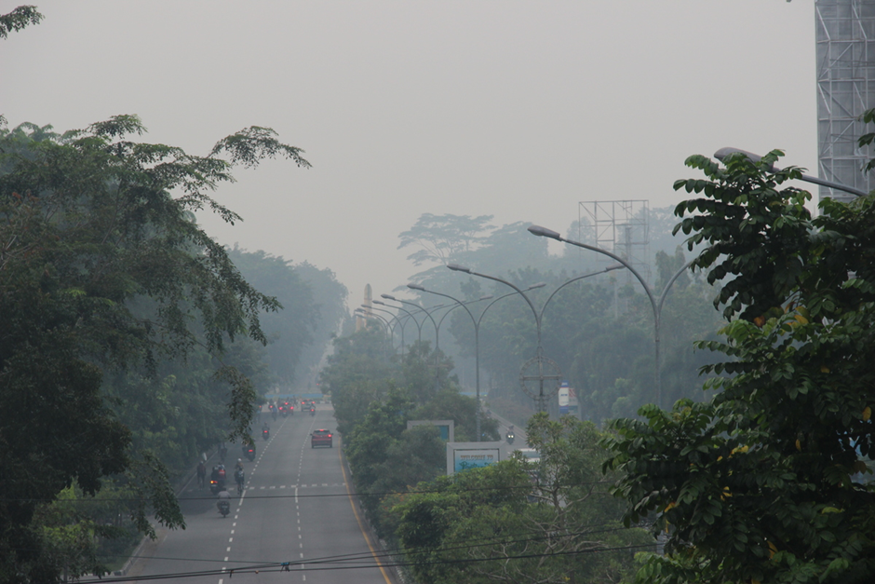
Source : Kompas.Id, 2023

BMKG information states that air quality in August 2023 will be unhealthy.
Published online by Pusat Penelitian Ilmu Sosial dan Humaniora Kontemporer.
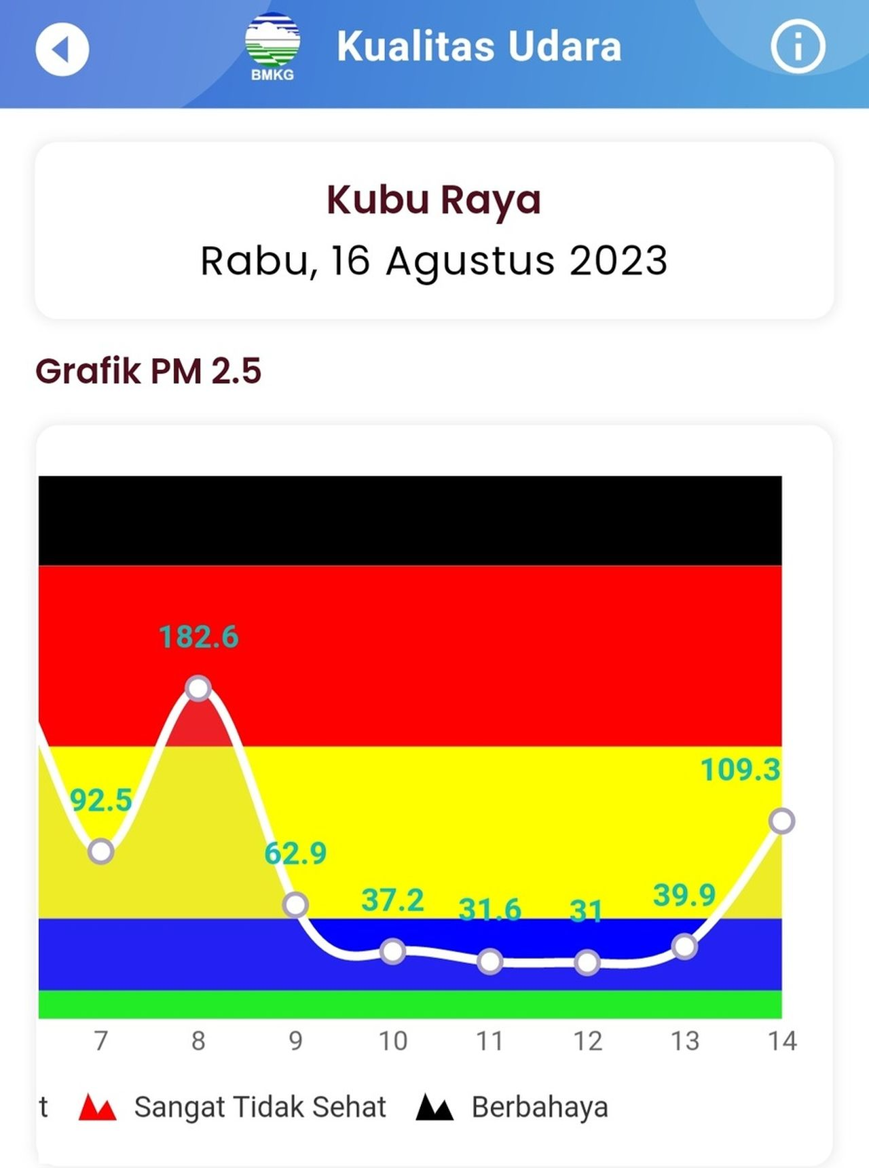
Source : Kompas.Id, 2023
West Kalimantan government policy, the government continues to strive to overcome forest and land fires in West Kalimantan. However, handling forest and land fires cannot only be carried out by the government together with the TNI and Polri, but also requires the participation of the community and the business world. From January to August 2023, the area of ​​land burned in West Kalimantan reached 12,537.57 hectares. In an effort to tackle forest and land fires in West Kalimantan, the TNI held a meeting with the Governor of West Kalimantan on the 23rd of the 8th month of 2023, at the West Kalimantan Governor's Office. The results of the meeting will be material that will be discussed in a limited meeting with President Joko Widodo and ministries/institutions in Jakarta. One of the peatlands that was burned apart from Kubu Raya and Pontianak was in Mempawah Regency, West Kalimantan. In direct observation of fire extinguishing by the community together with the TNI and Polri (Kompas.id, 2023). In this case, the governor of West Kalimantan also said that solving forest and land fires requires working together with the community, ministries, institutions and the business world, in addition to enforcing applicable laws. It can be seen in figure 2.
Figure 2. Meeting between the governor of West Kalimantan and the TNI and POLRI
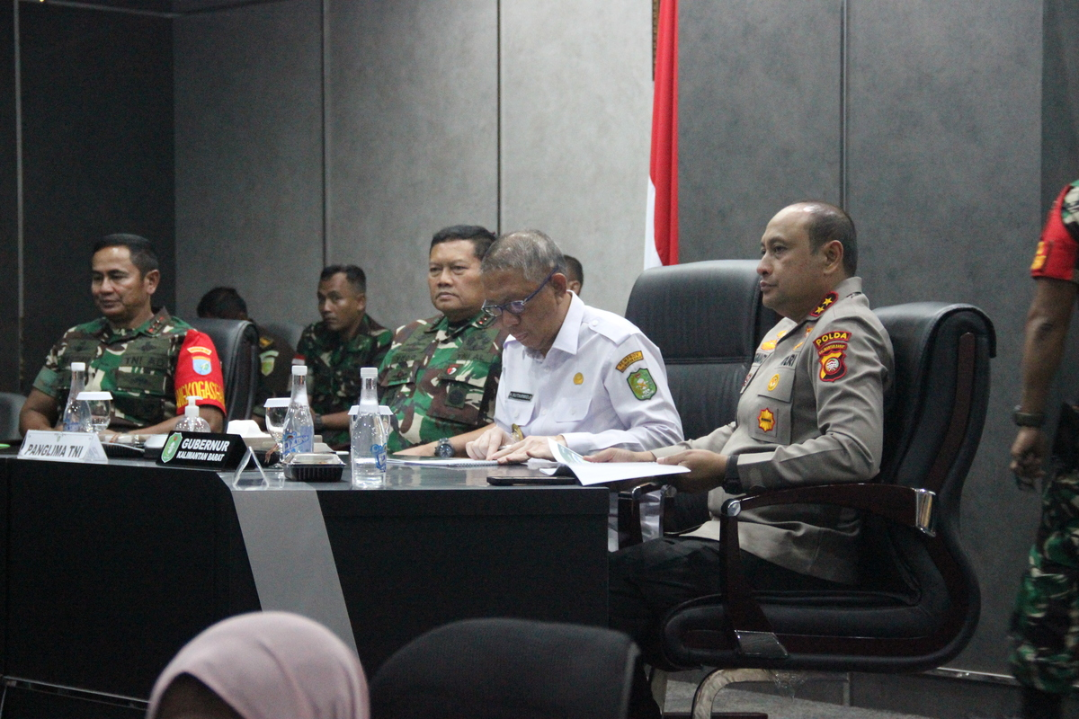
Source : Kompas.Id, 2023
During the meeting, it was announced that soldiers in the field carrying out fire extinguishing must be equipped with adequate equipment. Apart from that, officers are also trying to ensure that water flows to the location of the fire. Efforts to extinguish forest and land fires in West Kalimantan will also be carried out using weather modification technology. The forest and land fire incident in West Kalimantan is also considered a complex problem, not just the result of El Nino which has an impact on the emergence of hotspots. Therefore, joint efforts from various parties are needed. The Governor of West Kalimantan explained that the area of ​​peat land in West Kalimantan is 2.8 million hectares. However, only 1 percent of the province's peatlands are still completely natural. Around 80 percent of the land has light and heavy damage, making it vulnerable to fires (Kompas.id, 2023).
Over the last few years, the West Kalimantan Provincial Government, the National Police, and the Ministry of Environment and Forestry have enforced laws related to forest and land fires, both against individuals and corporations. In 2019, for example, there were 20 cases of forest and land fires which resulted in administrative sanctions being imposed on corporations. That year, there were also 67 cases involving the sealing of corporate land. Apart from that, in 2019, there were 157 cases that were followed by sanctions in the form of warning letters from the Governor of West Kalimantan to corporations. Still in the same year, there were five cases of forest and land fires which resulted in criminal sanctions against corporations. In 2019, there were also 26 cases of forest and land fires related to individuals. Then in 2022, there were 98 cases of forest and land fires which were followed by warning letters from the Head of the West Kalimantan Environment and Forestry Service against corporations. Apart from that, there will also be two cases of forest and land fires in West Kalimantan related to individuals in 2023.
Published online by Pusat Penelitian Ilmu Sosial dan Humaniora Kontemporer.
The West Kalimantan Environment and Forestry Service explained that, based on monitoring in August 2023, there were 128 hot spots in West Kalimantan. The hot spots are spread across Ketapang Regency in 88 locations, 12 locations in North Kayong Regency, 7 locations in Melawi Regency, and 21 locations in Kubu Raya Regency. Some of these hot spots are indicated to be on land owned by four corporations in the forestry and palm oil plantation sectors. The hot spots indicated on corporate land are in Kubu Raya Regency and Ketapang Regency.

West Kalimantan Government's Efforts To Deal With Forest And Land Fires
Apart from the legal efforts carried out by the West Kalimantan government, other efforts were carried out through weather modification technology which was implemented by the Disaster Information Task Force of the West Kalimantan Regional Disaster Management Agency in August 2023. Then patrols were carried out on peatlands in West Kalimantan to anticipate the impact of El Nino. Preparation for facing the longer period. dry as El Nino will occur in June 2023, the Government of Pontianak City, West Kalimantan continues to carry out activities (S. N. Qodriyatun, 2014). The government immediately formed a fire prevention task force. It can be seen in figure 3.
Figure 3. Preparation of facilities and infrastructure to anticipate forest fires
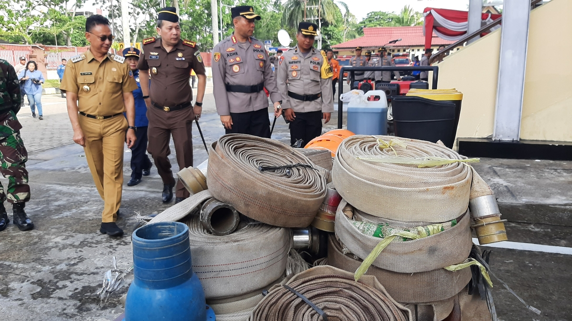
Source : Kompas.Id, 2023
The Mayor of Pontianak said, "We are now starting to anticipate forest and land fires (in May 2023), looking at previous experiences, fires in a number of peatlands occurred in July after three weeks of no rain. "Because if the weather is hot for a week or more and it doesn't rain, it's vulnerable to fires."
From June to August, peatland fires occurred in six locations in Pontianak City with an area of ​​around 20 hectares. The Pontianak City Government, due to this incident, had to seal five burned areas. The land fires that have occurred in West Kalimantan have almost certainly been triggered deliberately by residents. They burned the land for the reason of clearing the land. To prevent major fires from occurring again during hot weather in certain months, a number of efforts must be made well in advance.
Other preventive efforts continue to be carried out, namely in the form of outreach, putting up warning banners and patrols. Patrols are carried out both day and night. You especially need to watch out for hot weather from late March to April. Apart from that, hot weather is also expected to occur in August-September. Prevention is important because once a land fire occurs in hot weather, the fire will be difficult to extinguish. When smoke appears at the location, extinguish it as soon as possible. If this can be done effectively, land fires like those that occurred last February will not happen again. It is known that Pontianak City has a peat area of ​​around 70 hectares, most of which is spread across South Pontianak District and North Pontianak District. The Pontianak City Police Chief is carrying out Operation Bina Karuna to prevent land fires. The aim of this operation is to carry out outreach to the community not to burn land.
Published online by Pusat Penelitian Ilmu Sosial dan Humaniora Kontemporer.
Socialization is carried out every day involving 75 personnel from the Pontianak Police. There were also personnel from the TNI, sub-districts, Regional Disaster Management Agency (BPBD), people who care about fire, and firefighters who were involved. Land fires from July to September occurred in a number of areas in West Kalimantan. One of them was a peatland fire of around 2 hectares that occurred in Sungai Raya District, Kubu Raya Regency. Kubu Raya Regency has the largest area of ​​peat in West Kalimantan, namely 521,517.17 hectares. Then the Ministry of Environment and Forestry sealed the forest and land fire locations belonging to four corporations in West Kalimantan. The supervisory team and forestry police from the Law Enforcement Center of the Ministry of Environment and Forestry for the Kalimantan Region sealed the location of forest fires and land belonging to four corporations in West Kalimantan in 2023. This can be seen in Figure 4.

Figure 4. KLHK seals the location of forest and land fires
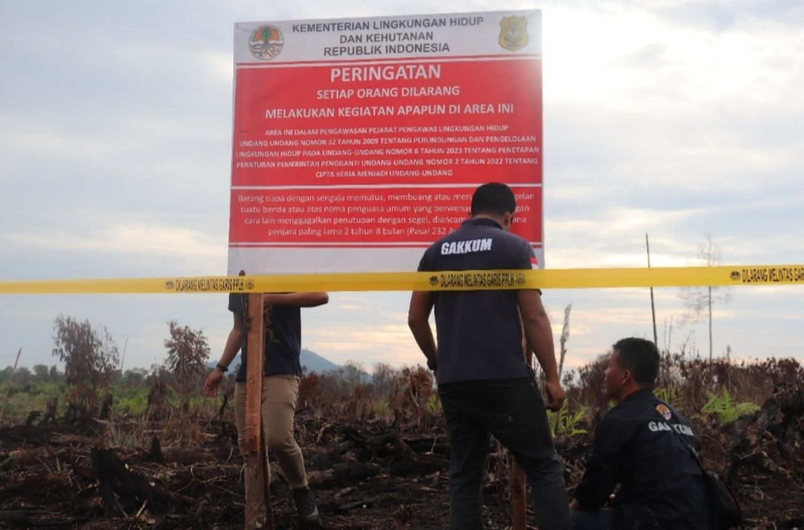
Source : Kompas.Id, 2023
A team of supervisors and forestry police from the Law Enforcement Center of the Ministry of Environment and Forestry for the Kalimantan Region sealed the location of forest fires and land belonging to four corporations in West Kalimantan in 2023 and those who violate them can be charged with civil or criminal law. Previously, in handling forest and land fires (karhutla), the Ministry of Environment and Forestry together with the police and the Attorney General's Office formed an Integrated Karhutla Law Enforcement Task Force. The Ministry of Environment and Forestry continues to coordinate with regional governments to make efforts to handle forest and land fires more effective, including law enforcement efforts.
Weather modification is carried out in West Kalimantan. Weather modification technology is implemented in West Kalimantan to prevent land fires (Nugroho, 2000). This is done as a form of mitigation to prevent forest and land fires from occurring. Management of forest and land fires requires a holistic approach and involves various parties. The following are several steps that can be taken to overcome forest and land fires. Can be seen in figure 5.
Figure 5. Weather modifications in the West Kalimantan region in 2023
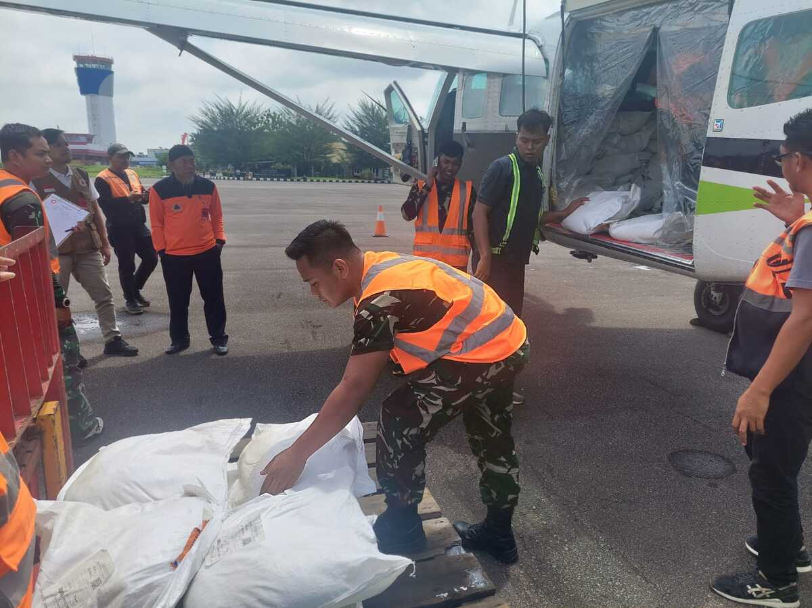
Published online by Pusat Penelitian Ilmu Sosial dan Humaniora Kontemporer.
Source : Kompas.Id, 2023

West Kalimantan Government Policy For Preventing Forest And Land Fires
The West Kalimantan government's policy to prevent forest and land fires is to provide education and outreach to the public regarding the dangers of forest fires and the importance of protecting the environment. As well as the formation of patrol teams to monitor forest and land areas that are vulnerable to fire. Restrictions on human activities that can trigger fires, such as burning rubbish, using open fires, and others. Land management: Implementing sustainable agricultural practices to reduce the risk of fire, such as stand management, planting non-flammable crops, and using irrigation systems. Use of controlled fire control methods to reduce fuel in forests and land. Technology and Innovation: Use of satellite and drone technology for real-time monitoring of forest fires so that fires can be detected more quickly. Development of applications or geographic information systems (GIS) that can assist in identifying fire-prone areas.
Environmental Conservation: Conservation efforts, protection of threatened species, and efforts to maintain biodiversity in the West Kalimantan region are important parts of environmental policy at the local level. City parks and environmental conservation efforts are the focus of efforts to protect the environment. Collaboration and Coordination: Cooperation between government, NGOs, local communities and the private sector to address the problem of forest and land fires together. Training and preparation of forest fire management teams so they can respond to fires quickly and effectively. Law Enforcement: Firmness in law enforcement against illegal practices that can cause forest fires, such as clearing land through uncontrolled burning. Environmental Restoration: Rehabilitation and reforestation of areas affected by fires to restore ecosystems damaged by fires (Adam, 2020).

Conclusion
The policy of the West Kalimantan provincial government in dealing with forest and land fires in 2023 is to read the methods carried out by preparing facilities and infrastructure to anticipate forest fires, the supervisory team and forestry police from the Law Enforcement Center of the Ministry of Environment and Forestry for the Kalimantan Region, sealing the locations of forest and land fires. owned by four corporations in West Kalimantan and carried out criminal acts, weather modification, providing education and outreach to the community, land management, technology and innovation, and developing applications or geographic information systems (GIS) that can help in identifying fire-prone areas and in environmental policy.
The environment requires support from local governments, NGOs, civil society and the private sector. Active participation from all parties is needed to fight for sustainable and pro-environmental policies. This includes strict monitoring of illegal activities that damage the environment, educating the public about the importance of conservation, and developing public policies that support environmental protection.
Published online by Pusat Penelitian Ilmu Sosial dan Humaniora Kontemporer.

References
Adinugroho, W. C., I N. N. Suryadiputra, B. H. Saharjo Dan L. Siboro. 2005. Panduan Pengendalian Kebakaran Hutan Dan Lahan Gambut. Wetland International-Ip Katalog Dalam Terbitan (Kdt). Bogor. 163 Hal.
Alwi, M. 2006. Perubahan Kemasaman Tanah Gambut Dangkal Akibat Pemberian Bahan Amelioran. Jurnal Tanah Tropikal, 12(2): 77-83.
Akbar, A., Sumardi, R. Hadi, Purwanto Dan M.S. Sabarudin. 2011. Studi Sumber Penyebab Terjadinya Kebakaran Dan Respon Masyarakat Dalam Rangka Pengendalian Kebakaran Hutan Gambut Di Areal Mawas Kalimantan Tengah. Jurnal Penelitian Hutan Tanaman, 8 (5) : 287-300.
Armanto, M. E. Dan E. Wildayana. 1998. Analisis Permasalahan Kebakaran Hutan Dan Lahan Dalam Pembangunan Pertanian Dalam Arti Luas. Lingkungan Dan Pembangunan, 18 (4): 304-318.
Bahri, S. 2002. Kajian Penyebab Kabut Asap Kebakaran Hutan Dan Lahan Di Wilayah Sumatera Bagian Utara Dan Kemungkinan Mengatasinya Dengan Tmc. Jurnal Sains Dan Teknologi Modifikasi Cuaca, 3(2): 99-104
Darwiati, W. Dan M. Nurhaedaj. 2010. Dampak Kebakaran Hutan Dan Lahan Terhadap Sifat Fisik Tanah. Jurnal Mitra Hutan Tanaman, 5(1): 27-37.
Daryono, A. 2001. Potensi Permasalahan Dan Kebijakan Yang Diperlukan Dalam Pengelolaan Hutan Dan Lahan Rawa Gambut Secara Lestari. Jurnal Analisis Kebijakan Kehutanan, 6(20): 71-101.
Kementrian Kehutanan. 2014. Statistik Kawasan Hutan 2013. Kementrian Kehutanan. Jakarta 107 Hal
Kompas.Id Penanggulanga Karhutla Di Kalimantan Barat Https://Www.Kompas.Id/Baca/Nusantara/2023/08/23/Penanggulangan-Karhutla-Di-Kalbar
Nugroho, S.P. 2000. Minimalisasi Konsentrasi Penyebaran Asap Akibat Kebakaran Hutan Dan Lahan Dengan Metode Modifikasi Cuaca. Jurnal Sains Dan Teknologi Modifikasi Cuaca, 1(1):1-8.
S. N. Qodriyatun, “Kebijakan Penanganan Kebakaran Hutan Dan Lahan Di Indonesia,” Polit. Ecol., Vol. Vi, No. Maret, Pp. 9–12, 2014.
S. S. Adam And H. Pasongli, “Evaluasi Area Kebakaran Lahan Dan Hutan Berbasis Hotspot Citra Modis Evaluation Of Land And Fores Fire Area Based Of Hotspot Modis Imagery,” Vol. 3, No. 1, Pp. 19–34, 2020
Tacconi, L. 2003. Kebakaran Hutan Di Indonesia: Penyebab, Biaya Dan Implikasi Kebijakan. Cifor. 1-28 Hal.
Tempo. Kebakaran Lahan Riau Meluas Http://Www.Tempo.Co/Read/News/2014/03/27/206565979/Kebakaran-Lahan- Riau-Meluas. Diaskes 2 Mei 2014.

Published online by Pusat Penelitian Ilmu Sosial dan Humaniora Kontemporer.

